|  |  |  |  |  |
| --- | --- | --- | --- | --- |
|  | INTERNATIONAL TELECOMMUNICATION UNION  **TELECOMMUNICATION STANDARDIZATION SECTOR**  STUDY PERIOD 2017-2020 | | Focus Group on Autonomous Networks (FG-AN) | |
| AN-I-xx | |
| Original: English | |
| **Question(s):** | | N/A | Virtual, 3-5 November 2021 | |
| **INPUT DOCUMENT** | | | | |
| **Source:** | | SRM University, Amaravathi, AP, India | | |
| **Title:** | | Student team “Conquerors” presentation – Build-a-thon – Data generation using Simulators. | | |
| **Contact:** | | Dr. V. Udaya Sankar  Assistant Professor, Dept. of ECE  SRM University-AP, Amaravati, India. | | Email: [udayasankar.v@srmap.edu.in](mailto:udayasankar.v@srmap.edu.in) |
| **Contact:** | | Sai Jnaneswar  Student  SRM University-AP, Amaravati, India. | | Email: sai_jnaneswar@srmap.edu.in |
| **Contact:** | | V.M.V.S. Aditya  Student  SRM University-AP, Amaravati, India. | | Email: vellampalli_medha@srmap.edu.in |

|  |  |
| --- | --- |
| **Keywords:** | Build-a-thon, Data, generation, simu5g, simulation |
| **Abstract:** | This contribution is a report on activities of team “conquerors” towards the Build-a-thon hosted by ITU FG AN in ITU AI/ML in 5G Challenge (2021). It will cover the simulator configurations, results obtained so far, and the open problems faced by the team. |

**1. Introduction**

As discussed in [Build-a-thon FG AN], the “conquerors” team registered for the Build-a-thon problem statement and worked to produce proof of concept (PoC) demo. This contribution is a report from the build-a-thon activity from team “conquerors” done as part of the ITU AI/ML in 5G Challenge.

**2. Problem statement**

1. Simulate 5G and 4G layer 2 such that resource block allocation data can be collected.

2. Collect data for various simulation scenarios.

Hypothesis:

1. Data is collected in csv format for various simulation scenarios.

Simu5g [[FGAN-I-125](https://extranet.itu.int/sites/itu-t/focusgroups/an/input/FGAN-I-125.docx)] was used as the simulator to generate data related to resource block allocation by base station. The two basic simulation scenarios used are as follows:

Figure1: Standalone (Left) and NR dual connectivity (Right) deployment. [*Ref: G. Nardini, D. Sabella, G. Stea, P. Thakkar, A. Virdis "Simu5G – An OMNeT++ library for end-to-end performance evaluation of 5G networks", IEEE Access (2020), DOI: 10.1109/ACCESS.2020.3028550*]

Simu5G is a simulator library based on NR (New Radio). It is based on the OMNET++ simulation framework and incorporates the models from the INET library. Simu5G simulates both the data plane of 5G RAN and the core network. It also provides heterogeneous 5G base stations called gnb. It also supports dual connectivity between LTE and 5G via the X2 interface. Simu5G version of 1.2.0 is used in this work.

INET Framework is an open-source library for the OMNET++ environment. It contains various modules and protocols for simulations. Simu5G requires an INET version of 4.3.2 or above.

OMNET++ is a C++ based simulation library and framework. It provides a framework for developing and creating network simulations. As part of this project, we have used OMNET++ 6

**3. Simulation scenarios**

Mainly, the 2 simulation scenarios considered are as follows:

3.a) Single cell with secondary GnB

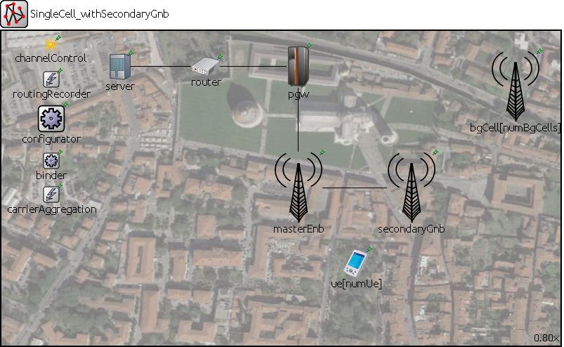

Figure2: NED file for SingleCell_withSecondaryGnb

3.b) Multi cell with secondary GnB

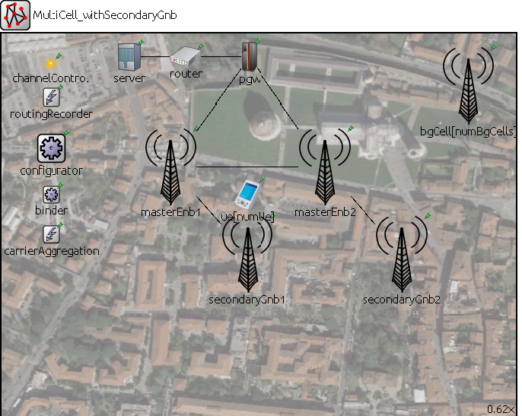

Figure3: NED file for MultiCell_withSecondaryGnb

The ini file parameters are as follows:

|  |  |
| --- | --- |
| **Parameter** | **Value** |
| eNodeB Transmission Power | 40dB |
| Fb Period | 10ms |
| Target BLER | 0.01 |
| BLER Shift | 5 |
| #Component Carriers | 2 |
| Carrier Frequency of CC1 | 2GHz |
| Carrier Frequency of CC2 | 6GHZ |
| #UE’s | 10 |
| UE mobility type | “RandomWaypointMobility” |
| UE speed | Between 5mps to 15mps |
| Dual Connectivity | True |
| # resource blocks for CC1 | 6 |
| # resource blocks for CC2 | 6 |
| #UE apps | 2 |
| Amount of UDP application on server (server.numApps) | #UE’s * #UE apps  =20 |

Table1: parameters for simulation

**4. Results**

The results are as follows

**4.a) Avg served blocks DL (vector) for (3.a Single cell with secondary GnB)**

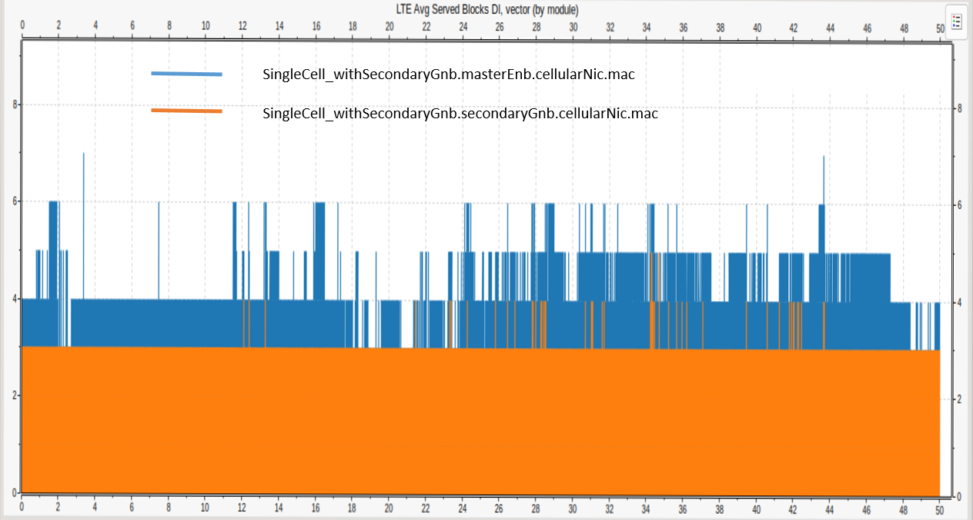

Figure4: Avg served blocks of gnb and enb with respective to the simulation time t=50sec. The blue and orange coloured line chart represents the avg served blocks for master enb and secondary gnb respectively in singleCell_withSecondaryGnb where the data flow i.e., CRB is Downlink

**4.b) Avg served blocks DL (vector) for (3.b Multi cell with secondary GnB)**

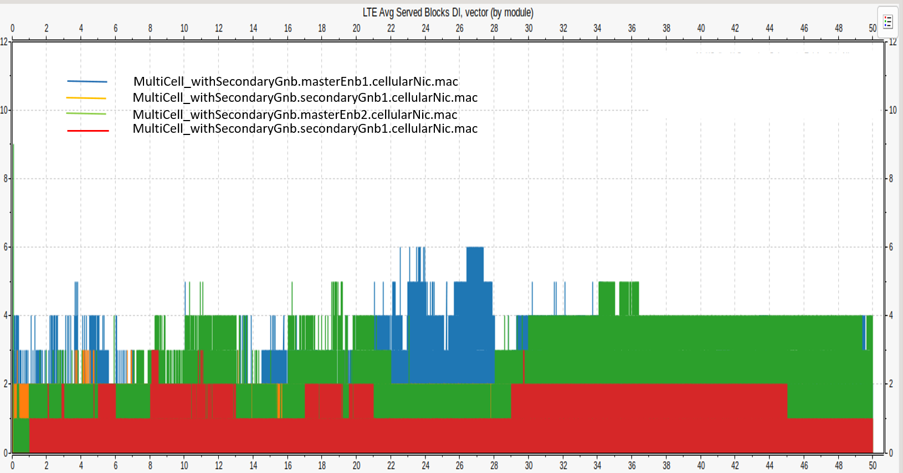

Figure5: Avg served blocks of two gnbs and two enbs with respective to the simulation time t=50sec. The blue, orange, green, red coloured line chart represents the avg served blocks for master enb1, secondary gnb1, master enb2 and secondary gnb2 respectively in MultiCell_withSecondaryGnb where the data flow i.e., CRB is Downlink.

**4.c) Avg served blocks UL (vector) for (3.a Single cell with secondary GnB)**

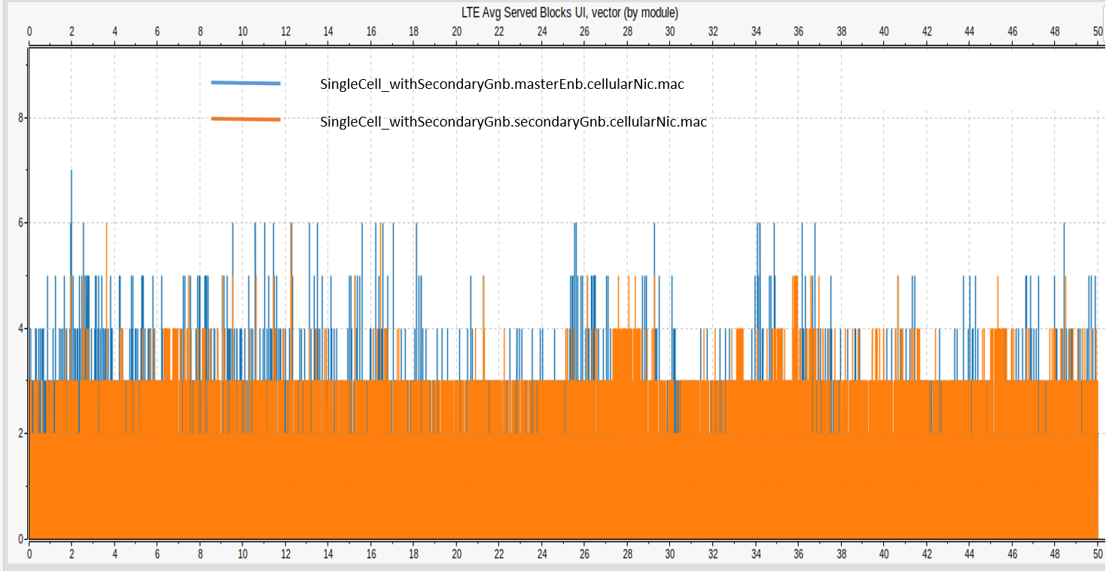

Figure6: Avg served blocks of gnb and enb with respective to the simulation time t=50sec. The blue and orange coloured line chart represents the avg served blocks for master enb and secondary gnb respectively in singleCell_withSecondaryGnb where the data flow i.e., CRB is Uplink.

**4.d) Avg served blocks UL (vector) for (3.b Multi cell with secondary GnB)**

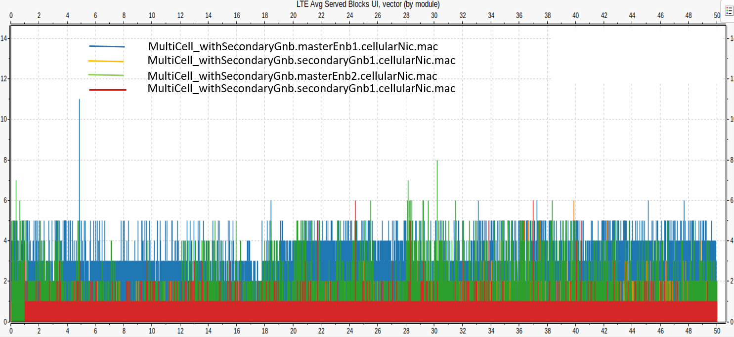

Figure7: Avg served blocks of two gnbs and two enbs with respective to the simulation time t=50sec. The blue, orange, green, red coloured line chart represents the avg served blocks for master enb1, secondary gnb1, master enb2 and secondary gnb2 respectively in MultiCell_withSecondaryGnb where the data flow i.e., CRB is Uplink.

Please refer the github link[1] to get outputs in csv file.

**5. Open problems**

The currently open problems and questions are as follows

1. There are zero resource allocation during some part of the simulation which means that there is no continuous allocation of resource blocks. Why the base station is not allocating resources continuously?
2. What kind of traffic pattern (e.g. full buffer) is being used when simulating the scenarios?
3. Why extracted CSV results file have repeated values of avgservedblocks?
4. Why the values of the resource allocation are different for the enb and gnb in dual connectivity.

**6. Future activities**

6.1 Extend the demo as discussed in [Build-a-thon FG AN], to include inputs from an Intent.

6.2 Integrate with the SRC and SINK and M nodes to form the closed loop.

**7. REFERENCES**

1. [github] <https://github.com/AdityaVMVS/Team-Conquerors>

2. G. Nardini, D. Sabella, G. Stea, P. Thakkar, A. Virdis "Simu5G – An OMNeT++ library for end-to-end performance evaluation of 5G networks", IEEE Access (2020), DOI: 10.1109/ACCESS.2020.3028550]

3. V. Raida, P. Svoboda and M. Rupp, "Real World Performance of LTE Downlink in a Static Dense Urban Scenario - An Open Dataset," GLOBECOM 2020 - 2020 IEEE Global Communications Conference, 2020, pp. 1-6, doi: 10.1109/GLOBECOM42002.2020.9348204.

4. <http://simu5g.org/install.html>

5. [[FGAN-I-125](https://extranet.itu.int/sites/itu-t/focusgroups/an/input/FGAN-I-125.docx)] Giovanni Nardini, Giovanni Stea, ITU-T FG AN “A mini-Tutorial on Simu5G”, <https://www.itu.int/webcast/archive2/t2021FG-AN>

[Build-a-thon FG AN] ITU-T FG AN-I-146 “Proposal for a “Build-a-thon” for ITU AI/ML in 5G Challenge (second edition, 2021), aligned with FGAN WG3” <https://extranet.itu.int/sites/itu-t/focusgroups/an/input/FGAN-I-114-R1.docx>

[Build-a-thon Challenge] ITU-T AI/ML in 5G Challenge problem statement “ITU-ML5G-PS-014: Build-a-thon(PoC) Network resource allocation for emergency management based on closed loop analysis” <https://challenge.aiforgood.itu.int/match/matchitem/45>

[FG AN use cases] ITU-T FG AN-I-142 Working document for use cases for Autonomous Networks

[FG AN arch] ITU-T FG AN-I-115-R1 Proposed initial draft of Architecture Framework for Autonomous Networks

**Appendix 1 Steps to repeat the demo**

1. Open omnet++ ide that is installed.
2. Open the Project Explorer Simu5g Simulations NR test_multicarrier Omnetpp. This directory help to open the ini file.
3. Similarly in the network folder of simulation folder contains the ned files.
4. To run the simulations use run symbol as shown Figure A.1.
5. It takes into Qtenv where one can select the configuration required to run as shown in Figure A.2.
6. After selecting the configuration click run button to simulate as shown in Figure A.3.
7. When simulation completes the results get stored in same directory as in step2.
8. Create an .anf file and open results in browse data as shown in Figure A.4.
9. Convert the graphs into csv files as shown in figure A.5.

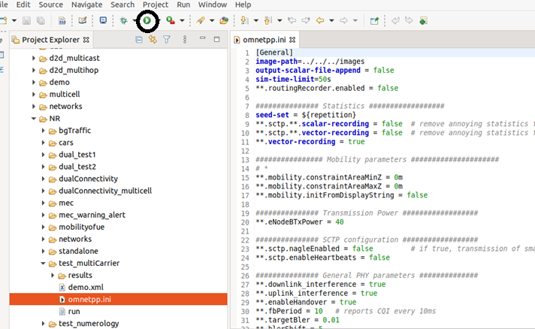

Figure A.1: Screenshot of running a simulation

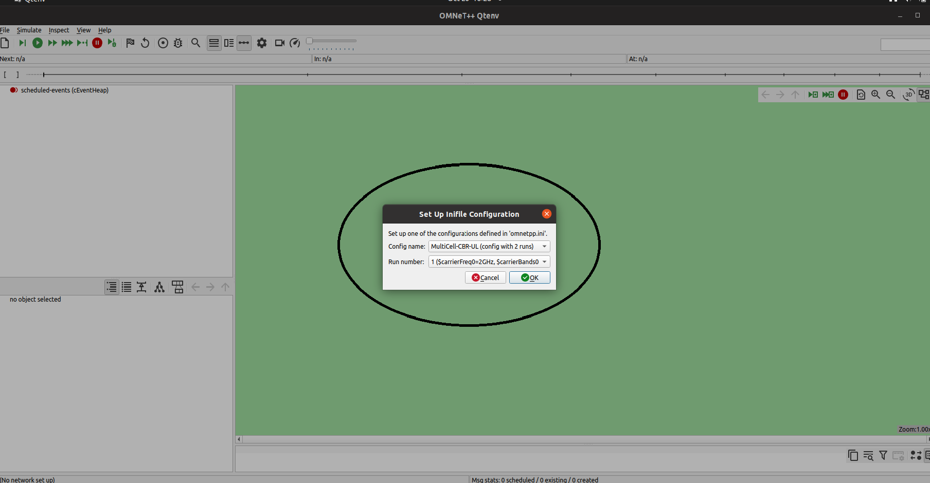

Figure A.2: Screenshot of Qtenv

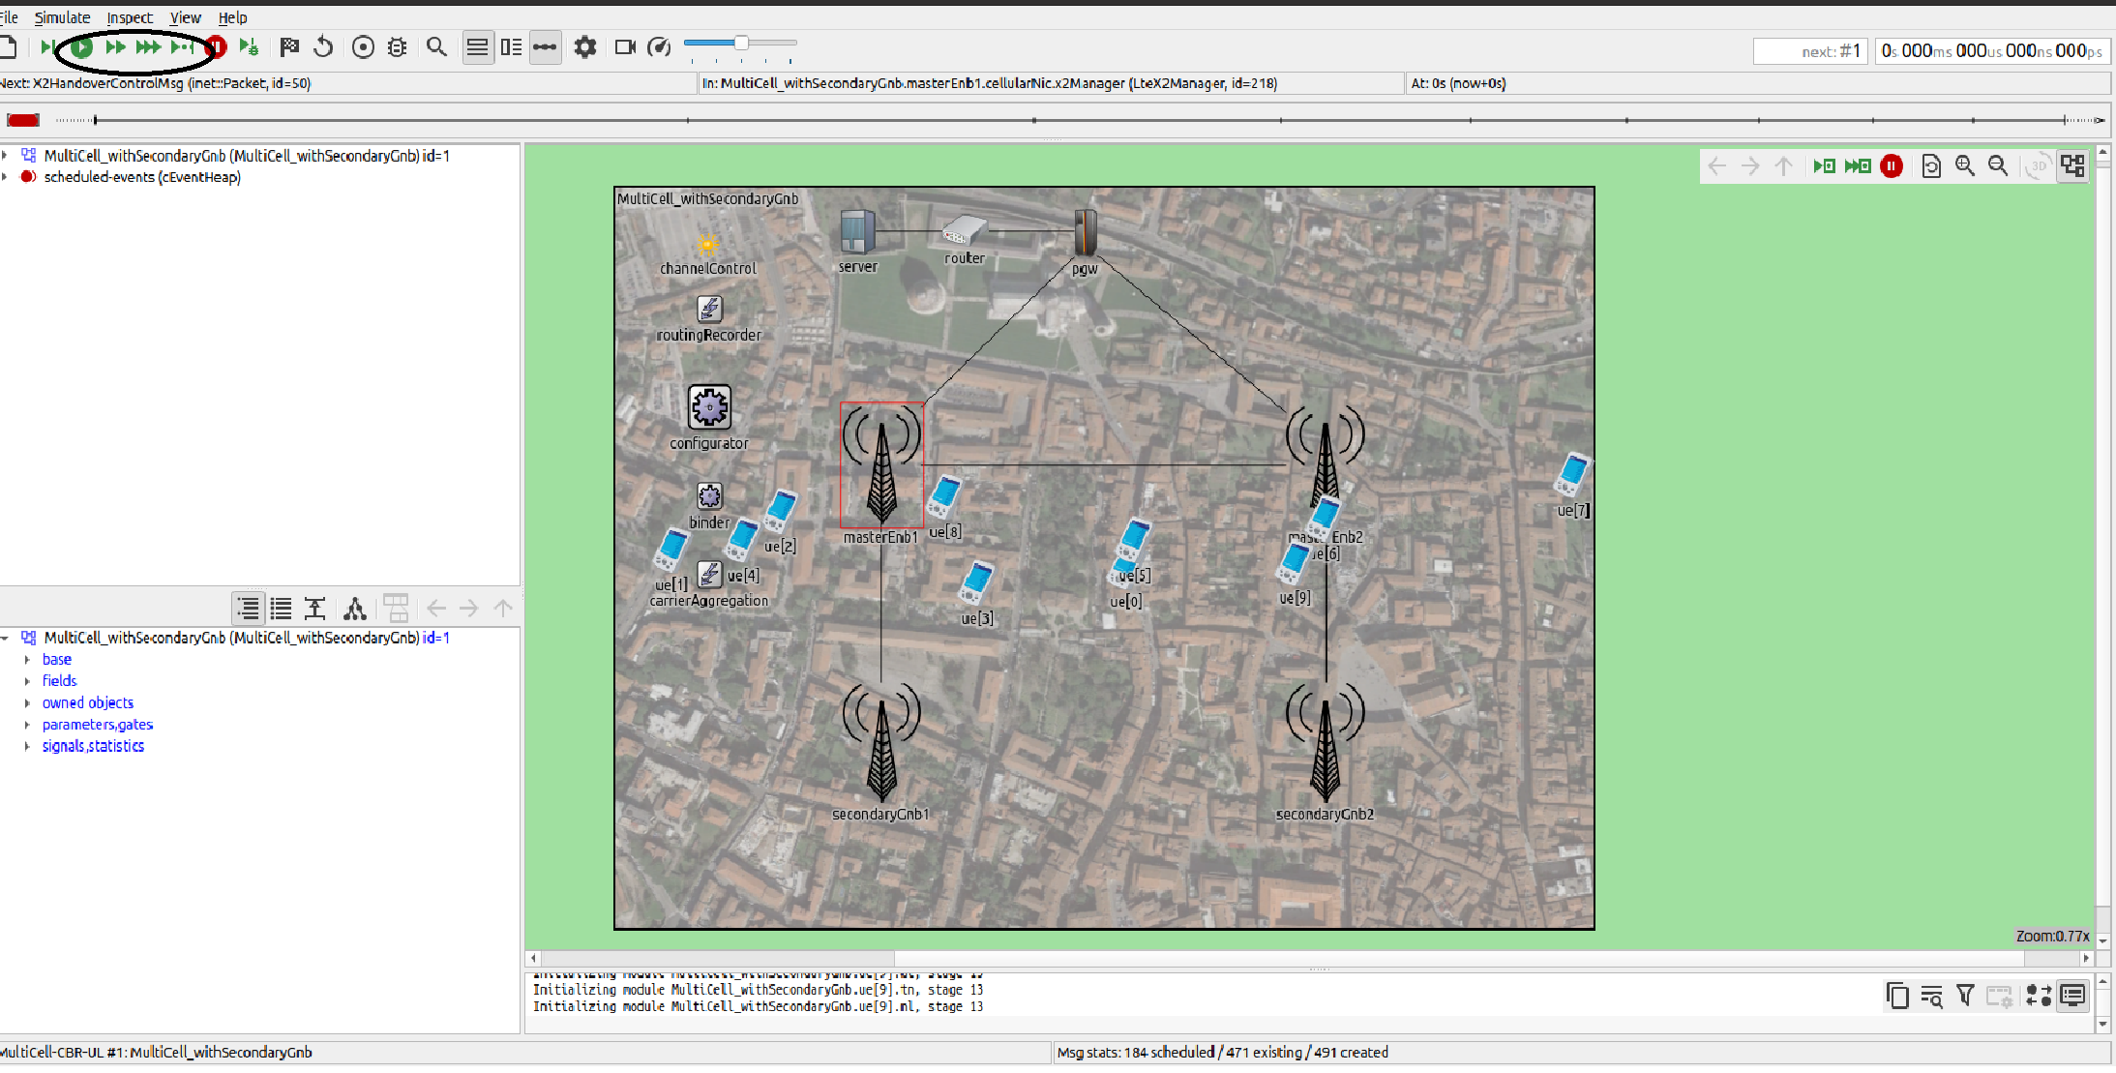

Figure A.3: Screenshot for running simulation

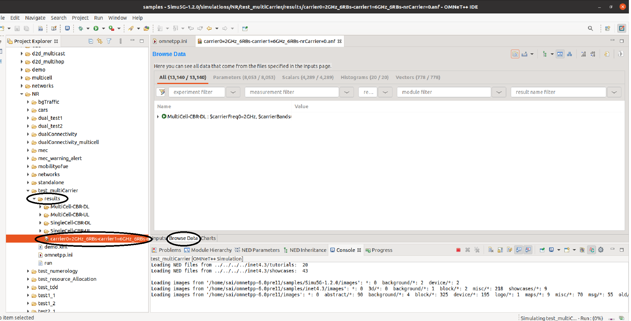Figure A.4: Screenshot for opening the output file.

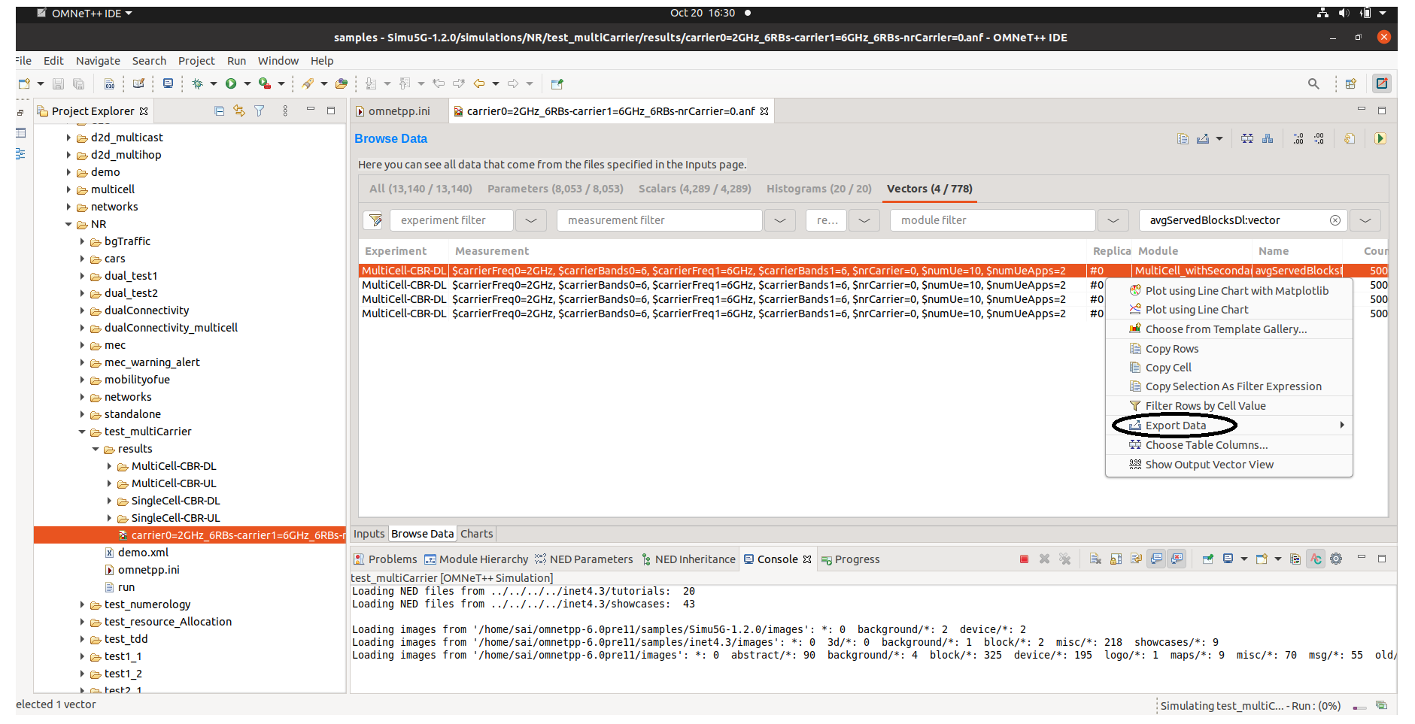

Figure A.5: Screenshot for converting csv file.

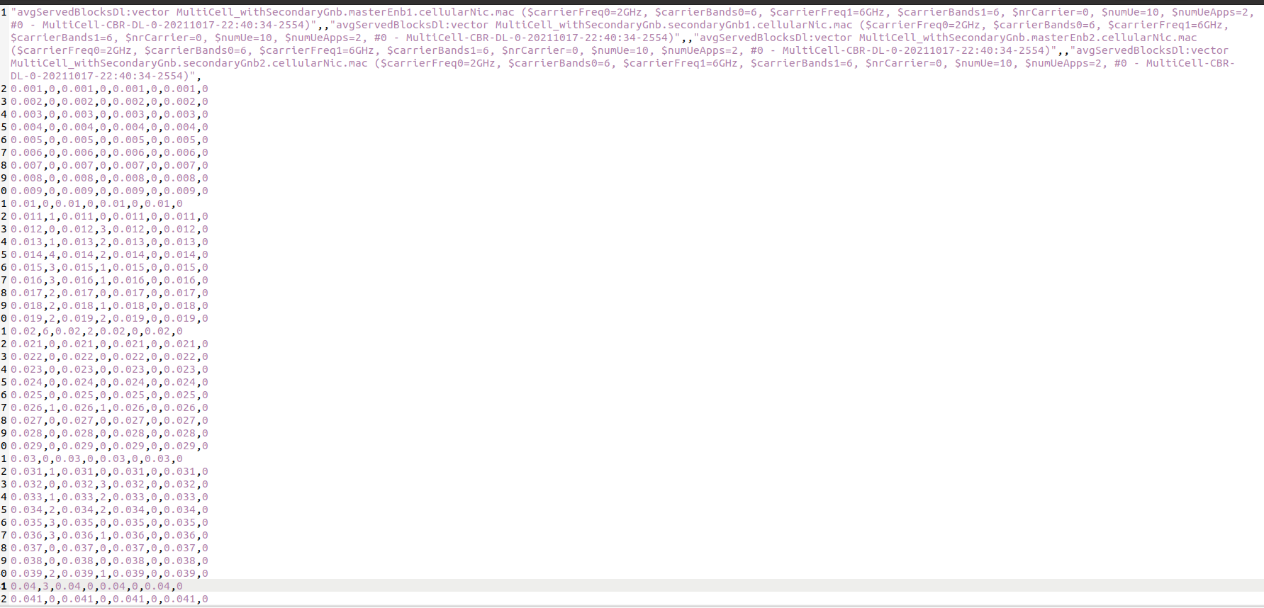Figure A.6: Screenshot of csv file for multicell_withSecondaryGnb Down Link

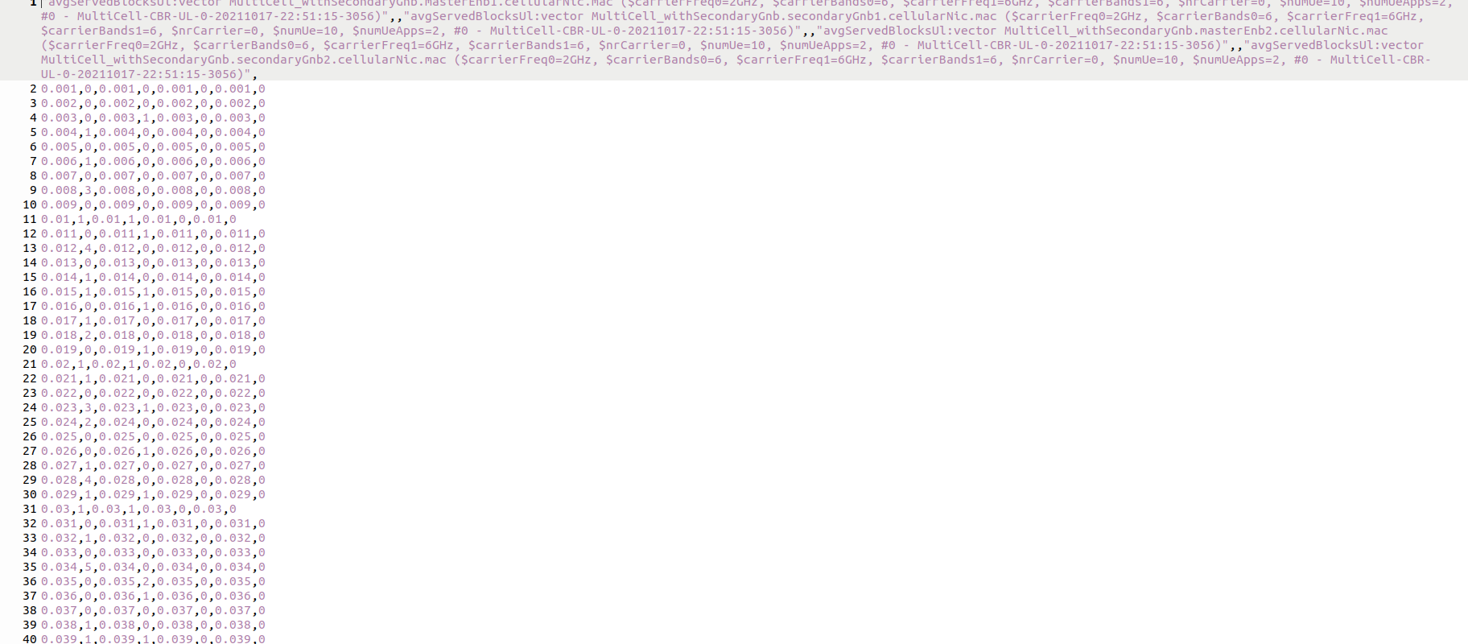

Figure A.7: Screenshot of csv file for multicell_withSecondaryGnb Up Link

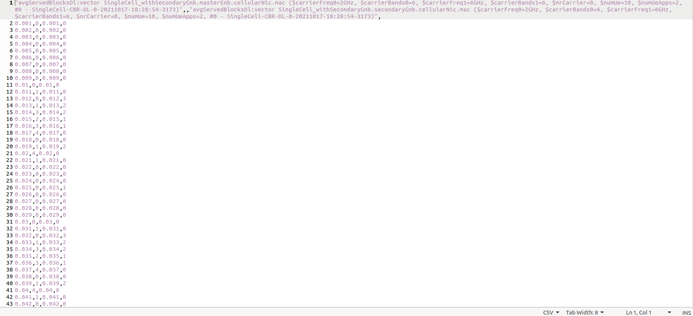

Figure A.8: Screenshot of csv file for singlecell_withSecondaryGnb Down Link

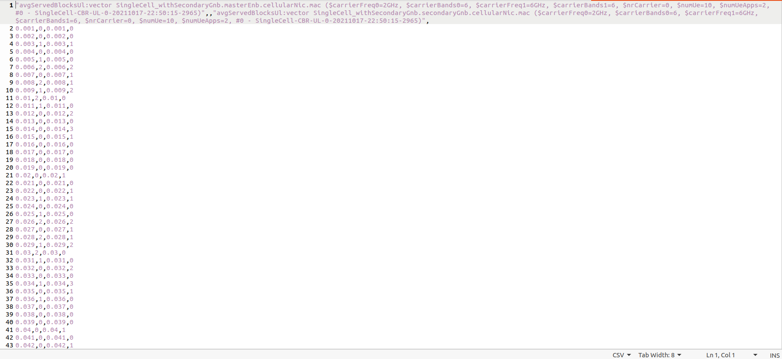

Figure A.9: Screenshot of csv file for singlecell_withSecondaryGnb Up Link

___________________